NRGscapes LAB
UAP Video & Imaging Case Intake
Version 2 – May 2026
Workbook
Field-to-lab workbook for evidence acquisition, metadata recording, conventional screening, and report readiness

Prepared by | Dr Andrew D. Morgan | NRGscapes LAB
Resource type | Case intake workbook and evidence-screening record
Primary use | New UAP video, still-image, IR, night-vision, CCTV, drone, or telescope footage
Companion document | NRGscapes UAP Video & Imaging Intake Protocol Technical Manual
Linked resource | NRGscapes LAB Pixel Geometry Field & Lab Guide and companion workbook
Core principle | Preserve the original file, document the chain of custody, screen conventional explanations, and only then proceed to advanced image analysis.
Workbook rule: This workbook is designed to be filled in each time new UAP video or imaging evidence is received. It is not a substitute for the technical manual; it is the case-record companion that captures the information needed to apply that manual consistently.

1. How to use this workbook
Purpose: Use this workbook as the front-end case record for every new video or image submission before interpretive image analysis begins.
This workbook mirrors the structure of the NRGscapes UAP Video & Imaging Intake Protocol Technical Manual. Each section contains a short explanation followed by a table or checklist to complete. Keep this document with the original evidence folder, metadata report, frame extraction log, screening outputs, and final case report.
Step | Action | Output
1 | Create a case ID and preserve the original file. | Case intake sheet and original evidence folder.
2 | Record chain of custody, transfer path, source details, and file handling. | Chain-of-custody log.
3 | Extract metadata and generate hash values. | Metadata report and SHA-256 file-integrity record.
4 | Record sighting geometry: location, time, UTC conversion, bearing, and elevation. | Sighting geometry worksheet.
5 | Complete astronomy, aviation, local operations, satellite/debris, weather, and artefact screens. | Conventional screening tables.
6 | Process known object controls where possible. | Known-object control record.
7 | Complete the conventional identification matrix before advanced analysis. | Evidence status summary.
8 | Proceed to advanced image analysis only after the above items are complete or explicitly marked pending. | Publication-ready report package.

End-to-end workflow diagram
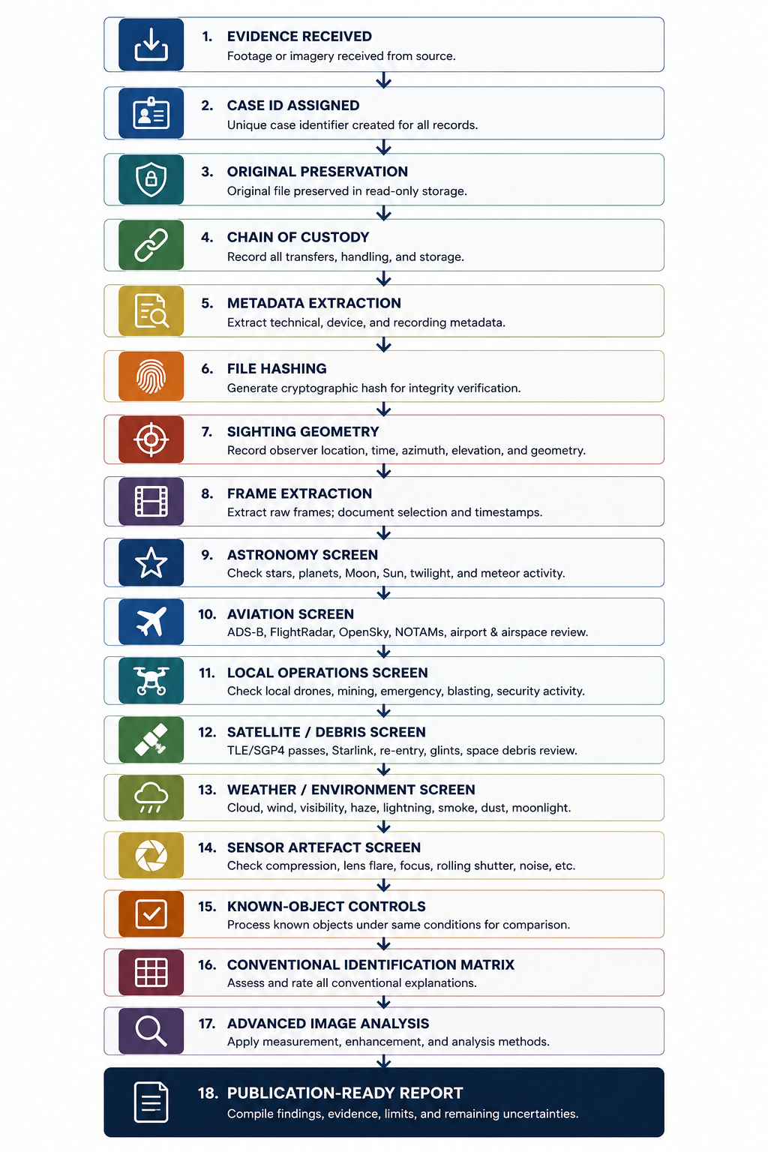
Figure 1. End-to-end UAP video and imaging case workflow. Use this sequence as the governing pathway for all case records completed with this workbook.

2. Case intake sheet
Purpose: Capture the minimum identifying information needed to open a new case file and connect all later outputs to one record.
Field | Entry / notes
Case ID
Date evidence received
Source/witness name or ID
Contact details / permissions
Capture date
Capture time or time window
Time zone
UTC conversion
Location name / site class
GPS latitude
GPS longitude
Observer elevation
Viewing azimuth / compass bearing
Estimated object elevation above horizon
Device/camera type
File type and filename
Original file available?
Transfer method
Compression risk
Number of witnesses
Witness statement available?
Short event summary

3. Evidence register and file preservation
Purpose: List each original and derived file so that the case record remains traceable from original evidence through to analysis outputs.
File ID | Filename | File type | Original / working / derived | Storage location | Notes
Required item |  |  | Status / evidence
Original file copied to read-only archive |  |  | [ ] Completed [ ] Pending [ ] Not available
Working copy created before analysis |  |  | [ ] Completed [ ] Pending [ ] Not available
Derived files stored separately |  |  | [ ] Completed [ ] Pending [ ] Not available
Original filename preserved |  |  | [ ] Completed [ ] Pending [ ] Not available
Transfer platform noted |  |  | [ ] Completed [ ] Pending [ ] Not available
Access permissions recorded |  |  | [ ] Completed [ ] Pending [ ] Not available

4. Chain of custody
Purpose: Document who captured, transferred, received, stored, and analysed the evidence. This is essential for publication-facing credibility.
Stage | Person / role | Date/time | Action taken | Evidence / notes
Capture
Initial storage
Transfer to NRGscapes
Receipt by custodian
Archive copy created
Working copy created
Frame extraction
Image analysis
Report preparation
Chain-of-custody note
If the evidence was supplied through a messaging, email, or social-media platform, state whether metadata may have been stripped or whether the received file is a compressed copy rather than the original source file.

5. File hashing and integrity record
Purpose: Generate SHA-256 hash values for the original file, working copy, and final evidence package. Hash values allow later verification that files have not changed.
Item | File/folder path | SHA-256 hash | Tool used | Date/time generated
Original file

Working copy

Extracted raw frames folder
Enhanced outputs folder
Final report package

6. Camera/video metadata worksheet
Purpose: Record reported metadata and extracted file metadata separately. Reported metadata can be useful, but extracted original-file metadata is stronger.
Metadata field | Reported by source | Extracted from file | Status | Notes
Device make/model |  |  | [ ] Verified [ ] Reported [ ] Missing
File format / container
Codec
Duration
Resolution
Frame rate
Bitrate
Creation date/time
Modification date/time
GPS tags
Focal length
Aperture
Exposure/shutter
ISO/gain
Software/editing tags
Audio present?
Recommended tools
Use ExifTool, MediaInfo, FFprobe/FFmpeg, and operating-system file properties. Where these disagree, record the conflict rather than choosing the most convenient value.

7. Sighting geometry worksheet
Purpose: Define the observation geometry before any astronomy, aviation, or satellite/debris screening is conducted.
Field | Entry / notes
Observer latitude (DMS and decimal)
Observer longitude (DMS and decimal)
Observer elevation above sea level
Local date
Local time window
UTC date/time window
Viewing azimuth / compass bearing
Estimated elevation above horizon
Search sector width (e.g. +/-20 deg)
Reference line visible?
Horizon / treeline / ridge / building / frame centre
Camera orientation
Tripod or handheld?
Camera motion during capture
Known fixed reference objects
Uncertainty in time
Uncertainty in direction
Uncertainty in object elevation

8. Frame extraction log
Purpose: Record how frames were extracted, selected, and excluded. Keep raw extracted frames separate from enhanced or annotated frames.
Frame ID | Timestamp | Frame no. | Included? | Reason included/excluded | Notes
 |  | [ ]
 |  | [ ]
 |  | [ ]
 |  | [ ]
 |  | [ ]
 |  | [ ]
 |  | [ ]
 |  | [ ]
 |  | [ ]
 |  | [ ]
Required item |  |  | Status / evidence
Frames exported at native resolution |  |  | [ ] Completed [ ] Pending [ ] Not available
No measurement frames cropped or resized |  |  | [ ] Completed [ ] Pending [ ] Not available
Extraction software recorded |  |  | [ ] Completed [ ] Pending [ ] Not available
Frame numbers retained |  |  | [ ] Completed [ ] Pending [ ] Not available
Raw frames archived before enhancement |  |  | [ ] Completed [ ] Pending [ ] Not available
Enhanced/processed frames stored separately |  |  | [ ] Completed [ ] Pending [ ] Not available

9. Astronomical screening record
Purpose: Check whether planets, stars, Moon, twilight, meteors, or fireballs could explain stationary or moving luminous objects.
Time local | Time UTC | Object | Mag. | Azimuth | Elevation | Angular separation from sighting | Candidate status
 |  | Venus
 |  | Jupiter
 |  | Saturn
 |  | Mars
 |  | Moon
 |  | Sun/twilight
 |  | Bright star(s)
 |  | Meteor/fireball reports
Astronomy interpretation rule: A planet or star may explain a stationary bright point source, but it does not explain separate moving objects unless the motion is caused by camera movement, autofocus, artefact, or misidentification.

10. Aviation screening record
Purpose: Search for aircraft tracks, emergency operations, transiting aircraft, and non-routine aviation near the observation window.
Source | Search radius | Time window | Aircraft/callsign | Altitude | Heading | Closest approach | Match status
FlightRadar24
ADS-B Exchange
OpenSky / ADS-B archive
Airport movements
NOTAM / airspace
Emergency services / RFDS / police / fire
Other

11. Local operations screening record
Purpose: Document whether local activities could explain lights or objects: mining, drones, helicopters, blasting, security, vehicles, rail, towers, or emergency operations.
Operation type | Checked with / source | Result | Documentation | Candidate status
Routine mine-site drone operations
Helicopter/fixed-wing operations
Emergency aviation

Blasting/flares

Security patrols/vehicle lights
Rail/ore train activity
Tower/plant lights

Survey contractors / LIDAR / thermal inspections

12. Satellite and space-debris screening record
Purpose: Use the sighting geometry to define a TLE/SGP4 satellite, Starlink, debris, rocket-body, flare/glint, and re-entry screen.
Parameter |  |  | Value / setting
Observer latitude
Observer longitude
Observer elevation
Local time window
UTC time window
Viewing azimuth
Minimum elevation threshold
Search sector
Magnitude threshold
TLE source/tool
Time local | Time UTC | Object name |  | NORAD ID | Type | Mag. | Az/el or closest approach | Match status
Satellite/debris interpretation rule: Satellites and orbital debris normally move smoothly across the sky. They are poor candidates for stationary bright objects but important candidates for moving point sources. A no-positive-match result should be distinguished from a complete exclusion unless a formal historical TLE table has been generated.

13. Weather and environmental screening record
Purpose: Record conditions that can influence visibility, refraction, glare, haze, scatter, apparent motion, and image artefacts.
Environmental factor | Data source | Value / result | Candidate relevance | Notes
Cloud cover

Visibility

Wind speed/direction

Temperature

Humidity/dew/fog

Rain/lightning

Dust/smoke/haze

Moonlight/twilight

Atmospheric refraction risk

Nearby light sources

14. Sensor and artefact screening record
Purpose: Screen for capture, compression, lens, autofocus, stabilisation, and foreground-object explanations before interpreting processed structures.
Artefact class | Evidence checked | Result | Status | Notes
Compression / macroblocking
Saturation bloom

Lens flare/internal reflection
Autofocus/focus breathing
Digital zoom/upscaling
Rolling shutter/stabilisation
Colour-channel misregistration
Hot pixels/sensor noise
Motion blur/camera shake
Foreground insect/bird/dust
Screen recording/re-encoding

15. Known-object controls
Purpose: Where possible, process known objects under the same parameters before applying advanced processing to unidentified targets.
Control type | Control file/source | Same parameters used? | Expected behaviour | Observed output | Notes
Venus/star point source |  | [ ] Yes [ ] No
Aircraft lights |  | [ ] Yes [ ] No
Drone/helicopter |  | [ ] Yes [ ] No
Satellite pass |  | [ ] Yes [ ] No
Vehicle/tower lights |  | [ ] Yes [ ] No
Blank sky/background |  | [ ] Yes [ ] No
Known luminous event/control |  | [ ] Yes [ ] No

16. Conventional identification matrix
Purpose: Summarise each candidate explanation using consistent evidentiary language. Complete this matrix before advanced image analysis is presented.
Candidate explanation | Evidence supporting | Evidence against | Status | Next step
Planet/star |  |  | [ ] Probable [ ] Possible [ ] Reduced [ ] No match [ ] Unresolved
Aircraft |  |  | [ ] Probable [ ] Possible [ ] Reduced [ ] No match [ ] Unresolved
Drone/helicopter/local operation |  |  | [ ] Probable [ ] Possible [ ] Reduced [ ] No match [ ] Unresolved
Satellite/debris |  |  | [ ] Probable [ ] Possible [ ] Reduced [ ] No match [ ] Unresolved
Meteor/fireball/re-entry |  |  | [ ] Probable [ ] Possible [ ] Reduced [ ] No match [ ] Unresolved
Weather/refraction/light scatter |  |  | [ ] Probable [ ] Possible [ ] Reduced [ ] No match [ ] Unresolved
Sensor/capture artefact |  |  | [ ] Probable [ ] Possible [ ] Reduced [ ] No match [ ] Unresolved
Unresolved anomalous object |  |  | [ ] Probable [ ] Possible [ ] Reduced [ ] No match [ ] Unresolved

17. Advanced image-analysis readiness checklist
Purpose: Use this checklist to confirm the case is ready for pixel geometry, enhancement, coherence-phase analysis, or other advanced methods.
Required item | Status / evidence
Original file preserved | [ ] Completed [ ] Pending [ ] Not available
Chain of custody completed | [ ] Completed [ ] Pending [ ] Not available
Metadata extracted or status clearly marked | [ ] Completed [ ] Pending [ ] Not available
Hash values generated | [ ] Completed [ ] Pending [ ] Not available
Sighting geometry recorded | [ ] Completed [ ] Pending [ ] Not available
Frame extraction log completed | [ ] Completed [ ] Pending [ ] Not available
Astronomical screen completed | [ ] Completed [ ] Pending [ ] Not available
Aviation screen completed or status marked | [ ] Completed [ ] Pending [ ] Not available
Local operations screen completed or status marked | [ ] Completed [ ] Pending [ ] Not available
Satellite/debris screen completed or status marked | [ ] Completed [ ] Pending [ ] Not available
Weather/environment screen completed | [ ] Completed [ ] Pending [ ] Not available
Sensor artefact screen completed | [ ] Completed [ ] Pending [ ] Not available
Known-object controls completed or justified as unavailable | [ ] Completed [ ] Pending [ ] Not available
Conventional identification matrix completed | [ ] Completed [ ] Pending [ ] Not available
Limitations listed before interpretation | [ ] Completed [ ] Pending [ ] Not available

18. Publication-ready report summary
Purpose: Use this page to draft the conservative summary that will appear in a paper, stakeholder report, or supplementary methods document.
Field | Entry / notes
Case summary

Most likely conventional candidate(s)
Objects remaining unresolved

Strongest evidence

Weakest evidence / limitations

Screens completed

Screens pending

Recommended classification language
Recommended supplementary files

Publication notes

Appendix A. Reusable AI case-assessment prompt
Purpose: Copy this prompt when uploading new footage, screenshots, metadata tables, or witness notes for structured assistance.
Reusable prompt: I am uploading UAP video or imaging evidence for a structured NRGscapes LAB case assessment. Please use the NRGscapes UAP Video & Imaging Intake Workbook and the UAP Video & Imaging Intake Protocol Technical Manual. Create or update the case intake summary, chain-of-custody table, metadata table, sighting geometry, astronomical screen, aviation screen, local operations screen, satellite/debris TLE screen, weather/environment screen, sensor artefact screen, known-object controls, conventional identification matrix, and publication-ready summary. Use conservative evidentiary language. Separate stationary objects from moving objects. Do not treat image-processing outputs as physical proof until conventional screening, metadata, chain of custody, and known-object controls have been addressed. Where information is missing, mark it as pending, unknown, provisional, or not assessable.

